**Best Locations for a Boston Fitness Venue**

William Scott Breckwoldt

January 9th, 2020

**1.Introduction:**

Growing up and living in the Greater Boston Area while also having a passion for sports, health, and fitness gave me the idea for this project. I figured people interested in the fitness club industry in Boston could benefit from seeing the most recent data for the neighborhoods as well as the locations of other fitness venues.

I will be using data wrangling and cleaning from various sources and data visualization with Folium, Choloropleth and GeoJson, and MatPlotLib. I will create histograms and interactive choloropleth maps that demonstrate the characteristics of each neighborhood that may affect fitness venue membership or attendance. I hope to conclude this project by providing those looking to open a fitness venue in Boston with some useful information about the area.

**2. Data**

**2.1 Data Wrangling**

First, I would need to gather general information on the fitness club industry and its customers looking specifically for factors that may lead to a gym’s success. I found useful sources for information of the fitness club industry such as the IHRSA and IBIS. I also found useful information on the neighborhoods on data.boston.gov and realestate.boston.com.

Second, I would need to find the location of all fitness venues in Boston. For this, I could use a Foursquare search and then add in missing points on Microsoft Excel after getting the address and coordinates on google maps.

**2.2 Data Cleaning**

I used Boston Neighborhood Demograhics, 2013-2017 American Community Survey from data.boston.gov to get the population, median household income, education attainment, and age distribution of the neighborhoods which I added to a worksheet in Excel. Also, a median monthly rents for a one-bedroom column was added thanks to realestate.boston.com to give us an idea of the property price of the various neighborhoods.

Gathering the addresses and coordinates from all the fitness venues I could find on google maps, was lengthy, but successful. After, I downloaded a GeoJson file from data.boston.gov that would allow me to outline the Boston neighborhoods and use them for my choropleth maps.

**3. Methodology**

After cleaning the data, I had what I would need to make the data visualizations that I wanted. I am going to make folium maps, as well as MatPlotLib to make histograms. The choropleth maps will have markers of the fitness venues colorized by category and will also demonstrate the population, median household income, percentage of population 20 to 34 years old, and percentage of population with a bachelor’s degree or higher.

**Maps**

Links:











Screenshots:

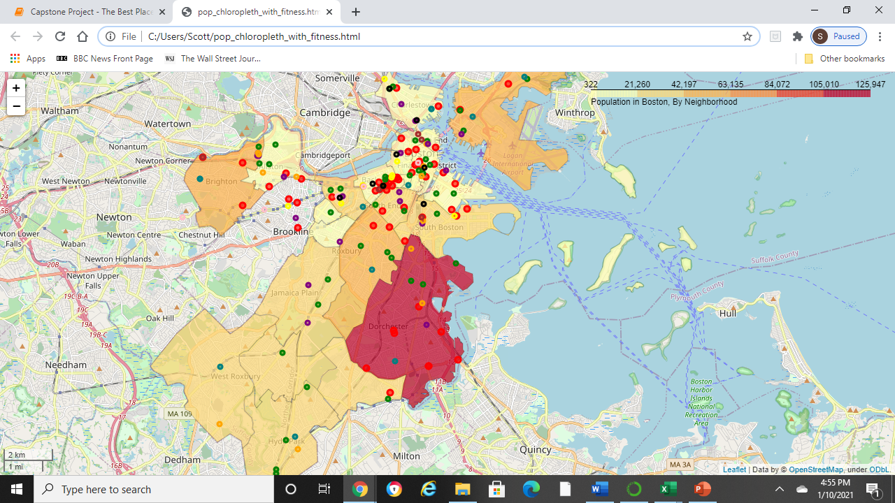

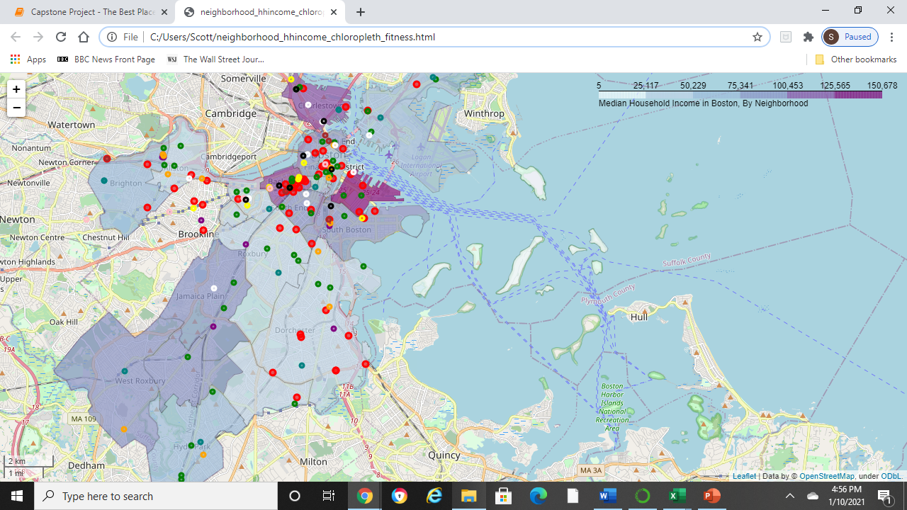

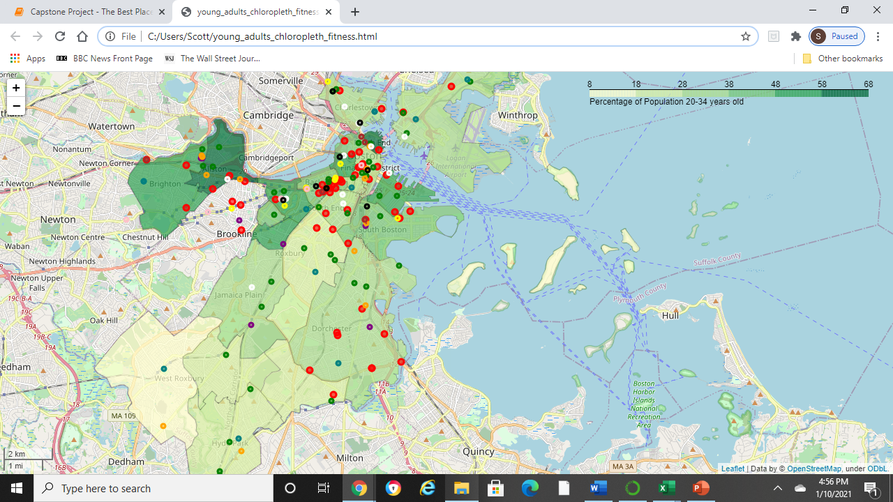

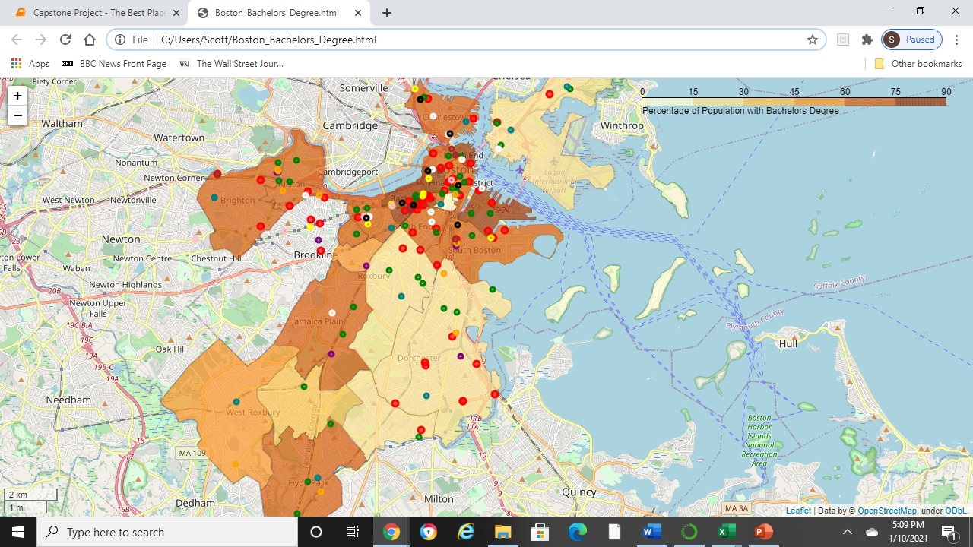

**Historgrams**

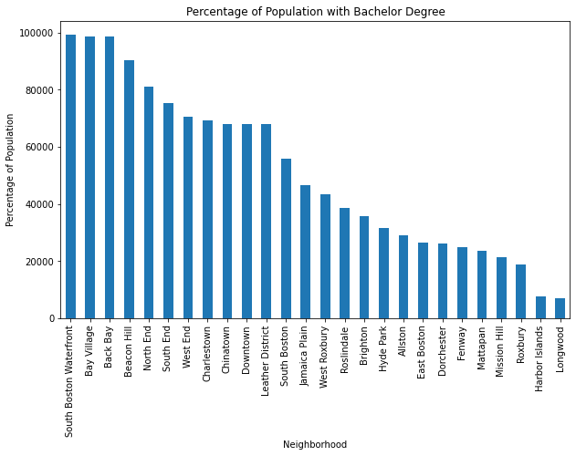

**4. Results**

Dorchester is by far the largest neighborhood, has a high young adult population and low rent and there are not any fitness centers in North Dorchester, however, it has a low median household income, along with Mattapan, Mission Hill, Longwood, Fenway, East Boston, and Allston. Downtown (including Chinatown and the Leather District) has the highest rent and already has plenty of fitness venues. Back Bay and Bay Village are also expensive and have plenty of fitness venues.

Jamaica Plain and Beacon Hill look like the best places to open a fitness venue according to these maps. Both have a high percentage of population with a Bachelor's degree and both have few fitness venues in the area. Jamaica Plain has a higher population and lower rent while Beacon Hill has the highest percentage of population with a bachelor's degree and a large young adult population.

**5. Discussion**

This project shows a good overview of the fitness club industry in the area by demonstrating the demographics and markers for all the fitness venues. However, it is far from being the reason to open a gym in the area.

Boston is a very developed city, there may be a reason there are fitness venues in Beacon Hill. Google maps could also be missing fitness venues or my data needs to be updates.

Also as a result of COVID-19, many fitness center venues have shutdown and people are starting to turn to home workouts and exercise so this project may not be useful until peope are returning to the gym.

I think this project would be a lot more useful if I could be more exact. If I could find a specific block or even property that would be ideal for opening a fitness venue, that would make this project this much better. Dividing the city up by postal code could be an option but then I would need to find data for postal codes.

6. Conclusion

Although I was able to locate what looks like a couple good neighborhoods to open a fitness venue, I feel that this project needs more data. There is not a lot of research or studies open to the public done on gym attendance and membership, but the IHRSA was helpful. I cannot be entirely sure if opening a gym in Beacon Hill would be a good financial decision either. Furthermore, I would have to look at the "For Sale" properties in the areas to determine where the very best locations would be. Nonetheless, this project provides a good overview of Boston's fitness club industry and would be helpful for someone interested on the topic. It could be even more useful with more knowledge of the fitness industry and individual fitness venues.